English | Maths | PSHE and Life Skills
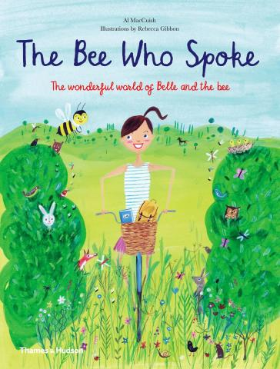  This term’s Talk for Writing key focus text is ‘The Bee Who Spoke’ by Al MacCuish .‘ Pupils will learn all narrative structures in order to develop their own narratives, writing to entertain.  GPS learning will include:  Developing sentences, punctuation and spelling in line with each pupil's phonics ability.  In phonics, we will be continuing to work in our groups to develop our phonics knowledge at each phase. We will also be writing to inform. | 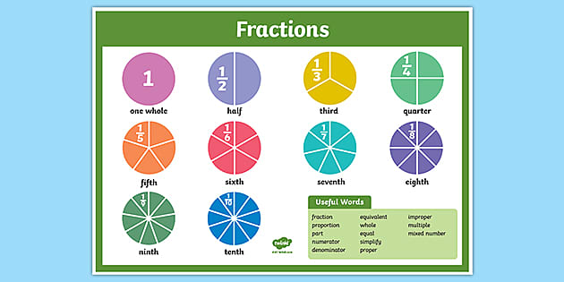  We will continue to work using the Mastering Number scheme, developing a Mastery approach, whereby pupils will develop a deep and secure knowledge of number relationships and knowledge that can be used to support fluency and problem solving.  Pupils will continue to develop their ability to talk about their numbers and explain their mathematical thinking.  We will be specifically focusing on : Fractions | Comets will continue to follow our PSHE curriculum, learning to manage feelings, relationships and choices at a level appropriate to their development.  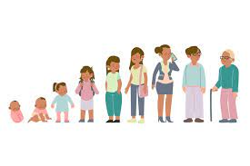  Pupils will be thinking about changing and growing. We will learn about the human life cycle, the ways our bodies change, including puberty. We will also discuss how our bodies are private and that families are all different.  Cooking: Exploring cooking skills using seasonal fruit and vegetables.
Understanding The World |   Comets Planning  Summer 1  2024  How does it start?  Our life skills focus will be: Hygiene | Computing
Comets will be learning about:  Food and farming:  We will consider the questions: Where does food come from and how have things changed over time?  What is a farm? What is an urban farm and what is a rural farm?    We will understand the past, present and future of farming and recognise aspects of change in national life within living memory.  In RE we will be learning about religion and belief in our community by exploring key features ofJudaism. We will know the story of Hanukkah and make a Menorah. |  | This term we will be focusing on data.  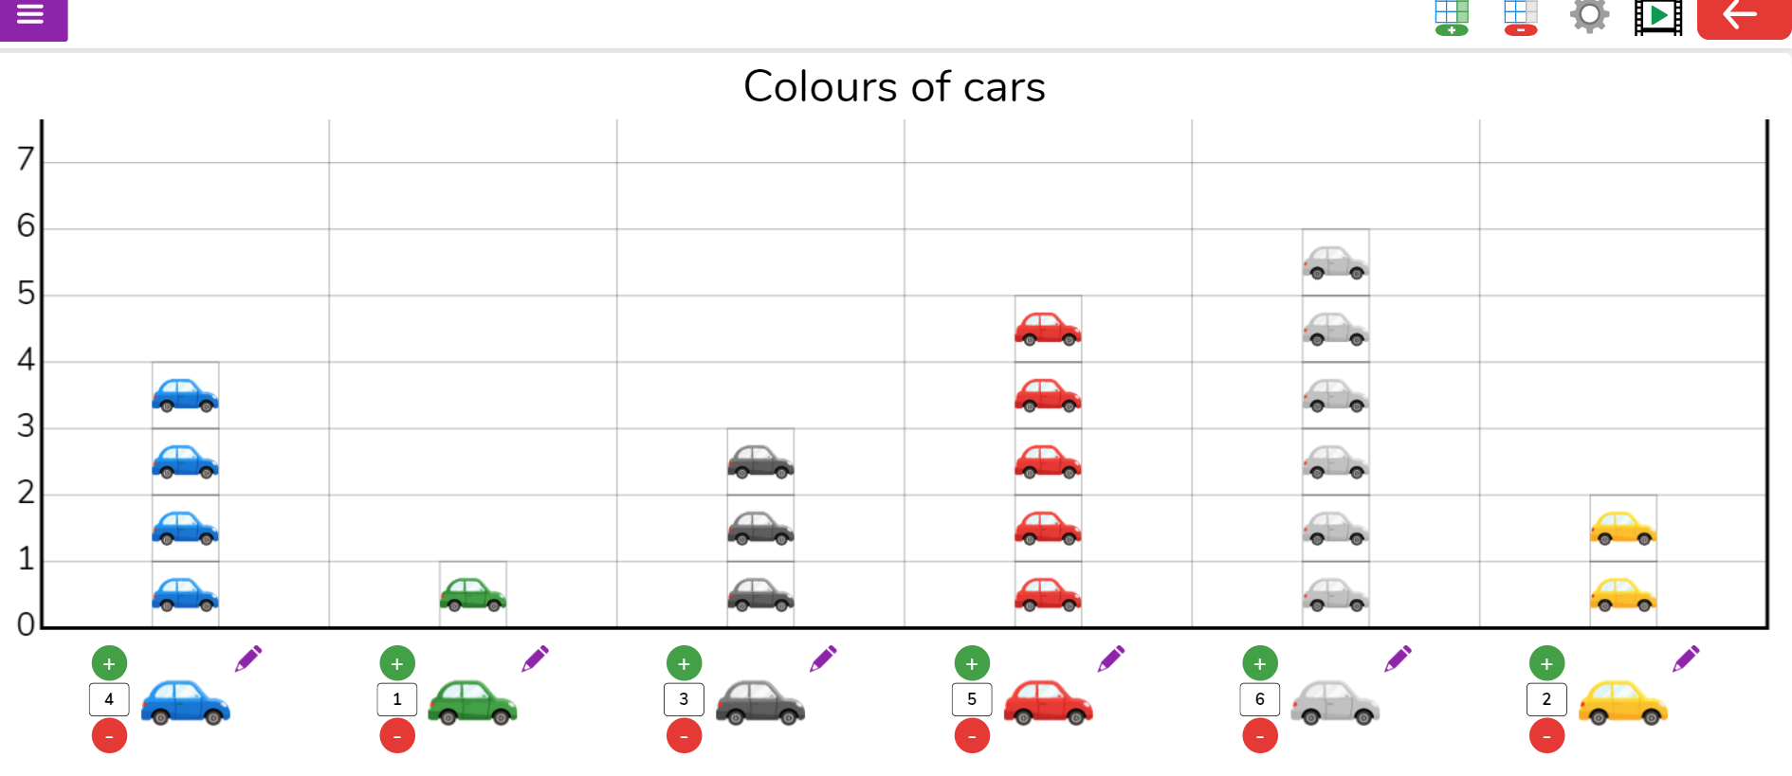  We will use Purple Mash 2 Count and 2 Graph.  We will be able to collect and discuss data collected and presented as a class  Create a basic pictogram and make simple editing choices such as changing the colour or changing the image.  Some of us will Interpret and construct simple pictograms, tally charts, block diagrams and simple tables using on or offline tools
Science | PE | Expressive Arts and Design
Comets will be learning about: Seasonal changes - Summer and  Plants  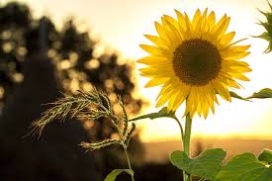  Pupils will be learning to make simple communications about the plants they see and talk about their features. To observe more closely and draw simple pictures of plants. To know that I can eat some plants and that some are not safe to eat.  Scientific enquiry: to record how things change, e.g. draw a simple diagram and carry out simple tests. Start to make comparisons between simple features of objects, materials or living things  Summer -seasonal change. We will look at changes over time, comparing Spring to Summer through studying the weather, plants and animals. | 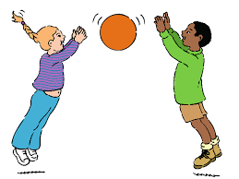  In Comets our focus will be:: Ball skills  We will be focusing on:  - Passing the ball with feet and with hands-  - Dribbling - The ball with feet  - Throwing - Over arm and underarm at a target  - Catching- different shaped balls  - Rolling- Underarm  - Balance- Agility-Coordination  - Throwing into a goal, hoop or target to score.  - Running- To receive/intercept a ball | 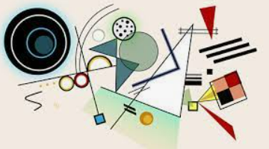  In Art we will be studying:  Collage using 2d shape  Comets will be studying the artist Kandinsky and focusing on the skill of collage. Pupils will be creating their own collages, developing their understanding of how shape and textures can be used to make a picture through tessellating and manipulating materials in different ways.  In music we will explore long and short sounds, through listening to music, composing our own and games.

