
Clarendon Primary Centre,
Buckingham Road,
Hampton, TW12 3LT
Tel: 020 8941 2623
Email: info@clarendon.richmond.sch.uk

Headteacher: Niall Dumigan
Head of Centre: Angela Mason

Summary of Clarendon Primary PE and Sports Premium
Total amount allocated for 2022/23 | £16,330
How much (if any) do you intend to carry over from this total fund into 2022/23? | £0
Total amount allocated for 2023/24 | £16,500
Total amount of funding for 2023/24. To be spent and reported on by 31st July 2024. | £16,500
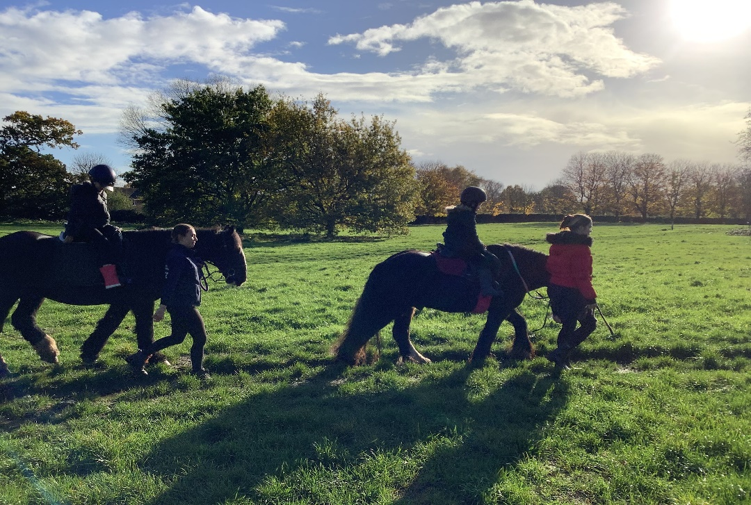

Review of last year’s spend and key achievements (2022/2023)

Activity/Action | Impact | Comments
PE curriculum, CPD, PE equipment and online planning resources.  Sensory circuits, OT and physio programmes developed for individual pupils  Active start and range of physical activities encouraged at all break times.  Resources purchased to improve variety and inclusivity of activities  Train additional staff in order to engage all pupils in outdoor learning and Forest school.  Subscription to Primary PE Planning on-line CPD videos, planning and resources.  PE lead to support to maximise the use of the on-line portal.  Regular updates at weekly staff meetings.  Observations and learning walks | All pupils receive at least 2 hours of PE (including OT and Physio exercises, sensory circuits and continuous provision) per week and have the opportunity to be physically active in school every day.  New Forest school leader in place  Staff knowledge improved. Pupil progress good. | All pupils seen to be physically active during learning walks carried out at break times.  All pupils able to find a suitable physical activity each day.  Pupils enjoy being outside and are physically active during Forest school whilst learning a variety of skills.  Subscription to Primary PE planning continued.

Key priorities and Planning

Action – what are you planning to do | Who does this action impact? | Key indicator to meet | Impacts and how sustainability will be achieved? | Cost linked to the action
To enhance the Physical development Curriculum by supporting pupils with sensory processing difficulties, enabling them to engage and learn within their learning environment  SDP – Priority with NEST training and implementation in Clarendon Primary.  To ensure that more able pupils are challenged through lessons, playtimes and interschool competitive sports activities. Subscription to Primary PE Planning on-line CPD videos, planning and resources.  The smooth transition of Forest school lead and continued participation in Forest school activities.  Horse riding, for a block of 6 weeks to be offered to all pupils in 3 Key stage 2 classes.  Specialist yoga teacher to provide CPD to teachers and yoga sessions for all pupils at Primary  Swimming for year 4 and 5 pupils to increase success at swimming in year 6 | All Primary teachers and teaching assistants- as they will be trained to lead on this activity.  All pupils with sensory processing difficulties.  All pupils  New Forest school leader trained and mentored.  All pupils in 3 key stage 2 classes attend Forest school for at least 1 term  All pupils in 3 Key stage 2 classes have the opportunity to learn to ride a horse.  All pupils at primary are able to take part in yoga activities every week  Pupils in years 4 and 5 | Key Indicator 1: Increased confidence, knowledge, and skills of all staff in teaching PE and sport.  Key indicator 3: Increased confidence, knowledge and skills of all staff in teaching PE and sport  Key indicator 2 -The engagement of all pupils in regular physical activity – the Chief Medical Officer guidelines recommend that all children and young people aged 5 to 18 engage in at least 60 minutes of physical activity per day, of which 30 minutes should be in school.  Key indicator 5: Increased participation in competitive sport.  Key indicator 4: Broader experience of a range of sports and activities offered to all pupils.  Key indicator 4: Broader experience of a range of sports and activities offered to all pupils.  Key indicator 4: Broader experience of a range of sports and activities offered to all pupils.  Key indicator 3: Increased confidence, knowledge and skills of all staff in teaching PE and sport | Primary teaching staff more confident to deliver effective sensory circuits, plans and PE lessons supporting pupils to undertake extra physical activities inside and outside of school, as a result improved % of pupil’s attainment in PE  More pupils meeting their daily physical activity goal, more pupils encouraged to take part in PE and Sport Activities.  Primary teaching staff more confident to deliver yoga sessions  More pupils engaged in Physical activities that can be continued out of school. | £1,800 for NEST training  £1000 for equipment  £395 PPE subscription  £4,000 towards the cost of the Forest school lead  £5,400  £4,000 towards the cost of the yoga specialist.  £1,586

Key achievements 2023-2024

Activity/Action | Impact | Comments
NEST training for all Primary teaching staff. Sensory circuits and sensory diets in place across Primary designed to meet their individual sensory needs. All PE lessons following the Alert, organize, calm sequence.  Broader experience of a range of sports and activities offered to all pupils:  Forest school  Horse riding  Swimming  Yoga  Enhanced opportunities at play times including cycling | Provision in place to meet the pupils’ Sensory and Physical outcomes in their EHCP and enable greater access to PE lessons.  Greater number of pupils engaged in physical activities and meeting their PE targets. | The NEST training has been an excellent resource for staff to access CPD and monthly  It is particularly important for pupils with special needs to trial a broad range of PE activities so they can find activities that are accessible.

Swimming Data
Meeting National Curriculum requirements for swimming and water safety. Priority should always be given to ensuring that pupils can perform safe self-rescue even if they do not fully meet the first two requirements of the National Curriculum programme of study

Question | Stats: | Further context  Relative to local challenges
What percentage of your current Year 6 cohort can swim competently, confidently and proficiently over a distance of at least 25 metres? | 33.3% | Our pupils have a range of complex needs including epilepsy, cerebral palsy and ASD with high anxiety. We only have 6 year 6 pupils this year. With swimming lessons provided over the last 3 years, these pupils have done well to get in the pool and start to swim. 2 out of 6 are confident swimmers now. The other 4 are making progress towards this target.
What percentage of your current Year 6 cohort can use a range of strokes effectively [for example, front crawl, backstroke, and breaststroke]? | 33.3% | Pupils gain confidence in water through the swimming lessons but not all pupils are able to swim using all of these strokes.
What percentage of your current Year 6 cohort are able to perform safe self-rescue in different water-based situations? | 100% | All pupils are taught and practice water safety.
If your schools swimming data is below national expectation, you can choose to use the Primary PE and sport premium to provide additional top-up sessions for those pupils that did not meet National Curriculum  requirements after the completion of core lessons. Have you done this? | Yes
Have you provided CPD to improve the knowledge and confidence of staff to be able to teach swimming and water safety? | No | We pay for a high number of qualified swimming coaches to teach our pupils. Our staff are trained on reducing anxiety and encouraging pupils into the water.

Signed off by:

Head Teacher: | Niall Dumigan
Subject Leader or the individual responsible for the Primary PE and sport premium: | Angela Mason – Head of Centre
Governor: | Zoe McGregor – Staff Governor
Date: | 15/07/24

