English | Maths | PSHE and Life Skills
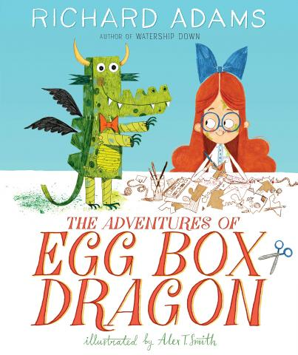  This term’s Talk for Writing key focus text is  The adventures of egg box dragon by  Richard Adams  ‘Pupils will learn all narrative structures in order to develop their own narratives, writing to inform.  GPS learning will include:  Developing sentences, punctuation and spelling in line with each pupil's phonics ability.  In phonics, we will be continuing to work in our groups to develop our phonics knowledge at each phase. We will also be writing to inform. | 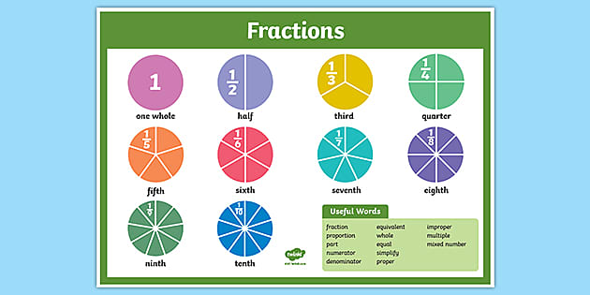  We will continue to work using the Mastering Number scheme, developing a Mastery approach, whereby pupils will develop a deep and secure knowledge of number relationships and knowledge that can be used to support fluency and problem solving.  Pupils will continue to develop their ability to talk about their numbers and explain their mathematical thinking.  We will be specifically focusing on : Shape and space |   Comets will continue to follow our PSHE curriculum, learning to manage feelings, relationships and choices at a level appropriate to their development.  Pupils will be thinking about self-awareness; being ready to listen and take part . We will learn about and describe some ways of  playing and working with  others so that everyone  feels happy and are able to  do their best. Demonstrate working  collaboratively towards  shared goals. Recognise occasions when we have worked as a team or in a group to achieve something.
Understanding The World |   Comets Planning  Summer 2  2024  Let’s be artists  Our life skills focus will be: Safety at the beach and sun safety | Computing
Comets will be learning about:    Human and physical geography – identifying the main physical and human features of local areas  Seasons Types of weather  Significant individuals: artists from around the world .  In RE we will be learning about religion and belief in our community by exploring key features of celebrations such as Sikh- Baisaki, Eid and World Humanist Day |  | This term we will be focusing on Programming and Algorithms  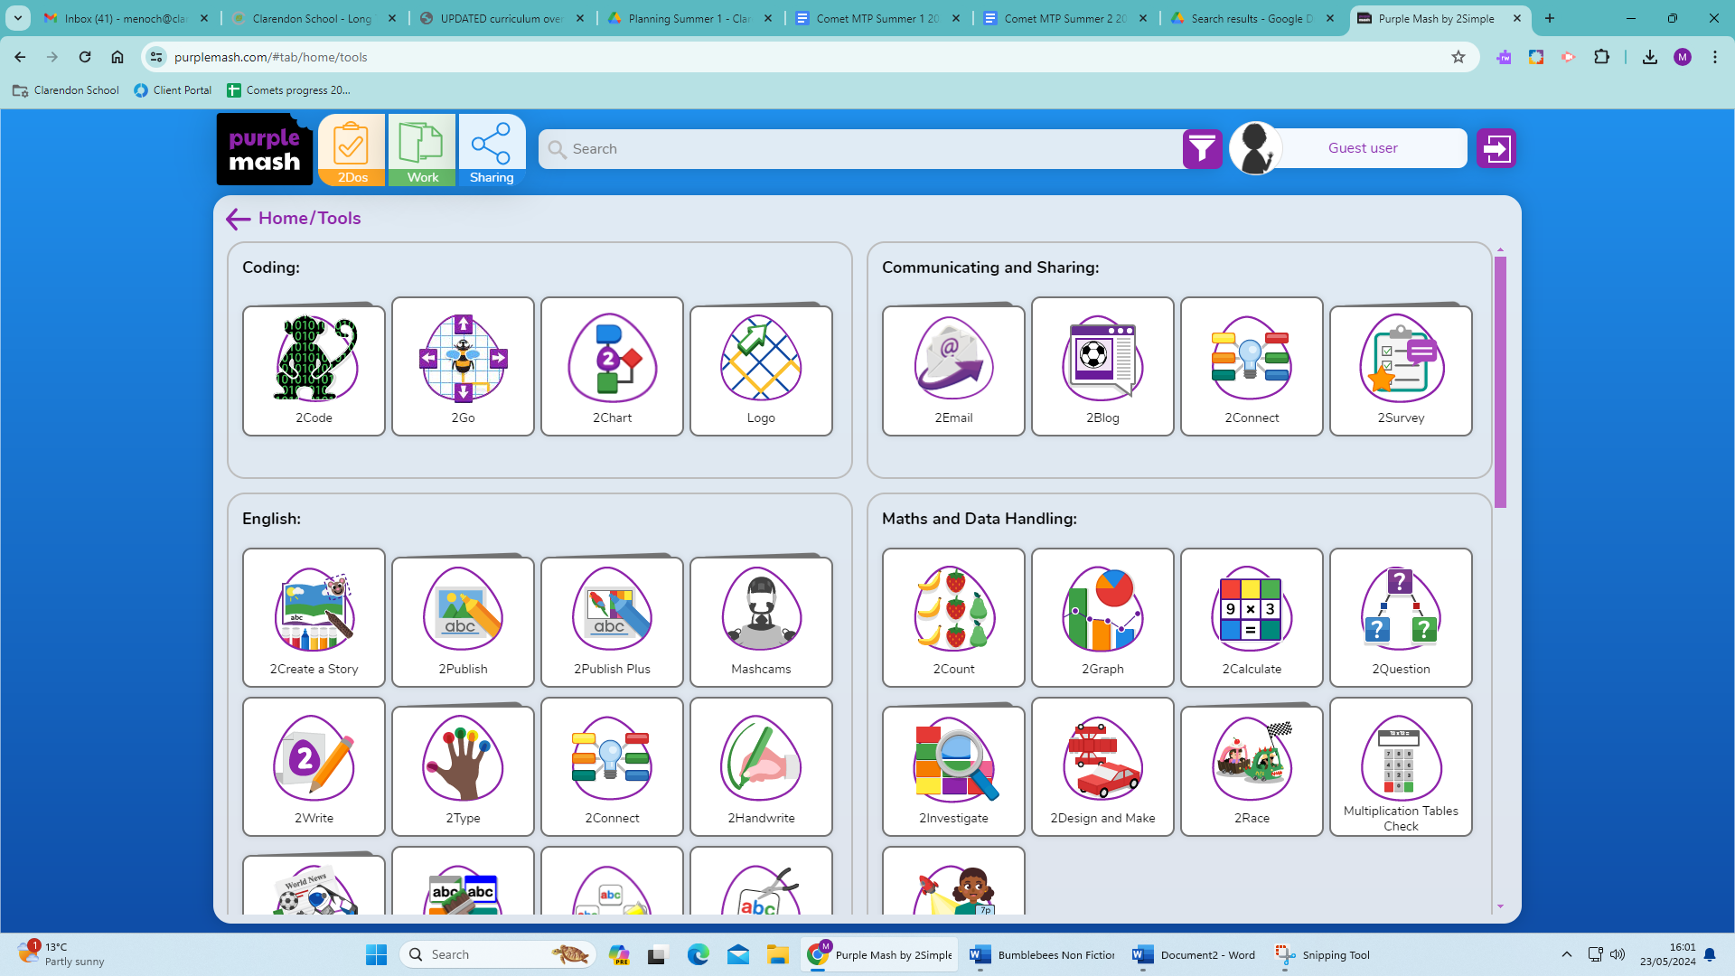  We will use Purple Mash 2 Go  We will be able to create and  program control technology to follow a simple route. Set simple instructions for online sprites and predict the outcome of a simple program (to move a floor robot or sprite) We will test a program and recognise when it needs debugging.
Science | PE | Expressive Arts and Design
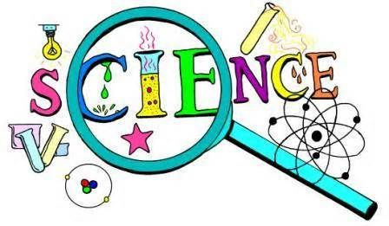  Comets will be learning about:  Seasonal changes - Summer we will explore ideas such as temperature changes, changes in plants and animals and complete our yearly work on seasons , making comparisons between the seasons.  Let's investigate - skills focus  Comets will apply their knowledge of scientific enquiry skills to plan a range of investigations linked to growing and life cycles and will explore ideas such as fair testing , pattern seeking and research skills. |   In Comets our focus will be:: Team skills and athletics  - Running/ pumping arms at various speeds  - Throw a variety of objects with some accuracy  - Jumping, bending knees and pushing off – being competitive to improve distance as a pair  - Co-operate and compete in a team in various running games.  - Leaping over throw down strips and low hurdles when moving | 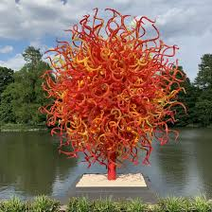  In Art we will be studying:  3D form , creating sculptures, from rigid and malleable materials.  We will learn about great artists, craft makers and designers.  Comets will be studying the artist Dale Chihuly  In music we will explore: Tempo - fast and slow sounds. We will listen to music from a range of genres and play fast music without getting louder and slow music without getting quieter.

